**Lesson 07 Demo 4**

**Ansible Modules**



**Steps to be performed:**

1. Executing Ansible modules with local server.

**Step 1: Executing Ansible modules with local server**

1.1 Run the below commands in the given sequence to execute different Ansible

modules.

**ansible webservers -m setup**

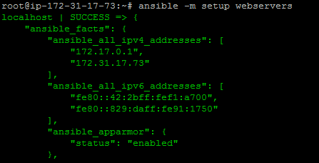

**ansible webservers -m shell -a 'hostname'**

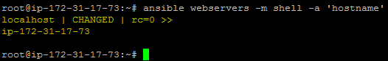

**ansible webservers -m apt -a 'name=git state=present' --become**

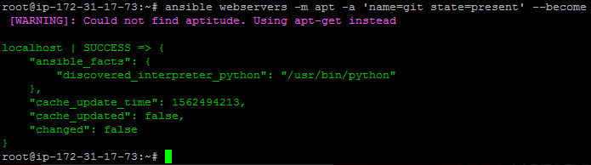

**ansible webservers -m file -a 'dest=/root/sample.txt state=touch mode=600 owner=root group=root' --become**

